NAME : WIJAYAWARDHANA W.A.H.A.

REGISTRATION NO. : 2019/E/166

SEMESTER : SEMESTER 04

DATE ASSIGNED : 23 MARCH 2022

HASH TABLE – LAB 05

EC 4070

DATA STRUCTURES AND ALGORITHMS

01.

**Code:**

import java.util.ArrayList;

import java.util.Scanner;

/**

* MaximumOccurrence method use for store the char values in array list.

*/

public class MaximumOccurrence {

ArrayList<Character> HashTableElement = new ArrayList<Character>();

int countingArray[][] = new int[128][2];

Scanner scanner = new Scanner(System.in);

String inputString;

// Default constructor.

public void setElements()

{

System.out.println("Enter the word : ");

inputString = scanner.nextLine();

for(int k =0; k<128;k++)

{

countingArray[k][0] = k;

}

}

/**

* setHashTableElement method use for set elements in hash table.

*/

// setHashTableElement method for setting HashTableElement array list.

public void setHashTableElement()

{

for(int i =0; i<inputString.length(); i++) // Adding element by element into array list.

{

HashTableElement.add(i,inputString.charAt(i));

inputString.indexOf(i);

}

}

/**

* customHashTable method use to add the char values to hash table according to the ascii value.

*/

public void customHashTable()

{

for(int i =0; i<HashTableElement.size(); i++)

{

int tempValue = HashTableElement.get(i)%127;

countingArray[tempValue][1] = countingArray[tempValue][1]+1;

}

}

/**

* findMaximum method use to find the maximum number of element

*/

public void findMaximum()

{

int maximum = countingArray[0][1];

int maximumIndex = countingArray[0][0];

for(int i =0; i<128;i++)

{

if(maximum < countingArray[i][1])

{

maximumIndex = countingArray[i][0];

maximum = countingArray[i][1];

}

}

char tempChar = (char) countingArray[maximumIndex][0];

int temp = countingArray[maximum][0];

System.out.println("Maximum occurrence : ");

System.out.print(tempChar + " "+temp);

}

/**

* main method use for create objects and calling methods.

* @param args

*/

public static void main(String[] args) {

MaximumOccurrence newObject = new MaximumOccurrence();

newObject.setElements();

newObject.setHashTableElement();

newObject.customHashTable();

newObject.findMaximum();

}

}

**Output:**

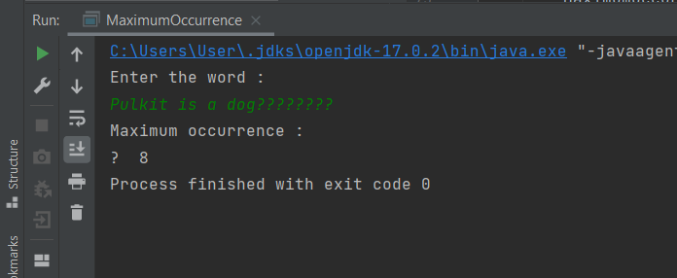

FIGURE 01 – OUTPUT

02.

**Code:**

package favoritegame;

import java.util.*;

/**

*

* @author 2019e166

*/

public class FavoriteGame {

int numberOfEntries;

HashMap<String,String> hashtable = new HashMap<String,String>(numberOfEntries);

HashMap<String,Integer> hashtableCount = new HashMap<String,Integer>(numberOfEntries);

Scanner scanner = new Scanner(System.in);

/**

* @setNumberOfEntries is for setting the number of entries.

*/

public void setNumberOfEntries()

{

System.out.print("Enter number of entries : ");

numberOfEntries = scanner.nextInt();

}

/**

* @setHashtable use for setting elements to hash map.

*/

public void setHashmap()

{

for (int i =0; i<numberOfEntries; i++) {

String nameString = scanner.next();

String gameString = scanner.next();

hashtable.put(nameString,gameString);

}

}

/**

* Count the elements and add them to hash map.

*/

public void countElement()

{

for(String elements : hashtable.values())

{

if(hashtableCount.containsKey(elements))

{

int count = hashtableCount.get(elements);

count= count+1;

hashtableCount.put(elements,count);

}

else

{

hashtableCount.put(elements,1);

}

}

}

/**

* Find the maximum count of the favorite game and football count.

*/

public void findMax()

{

int maxCount = 0;

String maxLikeGameName = " ";

for(String element : hashtableCount.keySet())

{

int gameCount = hashtableCount.get(element);

if(maxCount <= gameCount)

{

maxCount = gameCount;

maxLikeGameName = element;

}

}

System.out.println(maxLikeGameName);

System.out.println("Football : " + hashtableCount.get("football"));

}

/**

* @printFootballCount use to get number of people who likes football.

*/

/**

* @param args the command line arguments

* @main for creating an object and calling methods.

*/

public static void main(String[] args) {

FavoriteGame favoriteGame = new FavoriteGame();

favoriteGame.setNumberOfEntries();

favoriteGame.setHashmap();

favoriteGame.countElement();

favoriteGame.findMax();

}

}

**Output:**

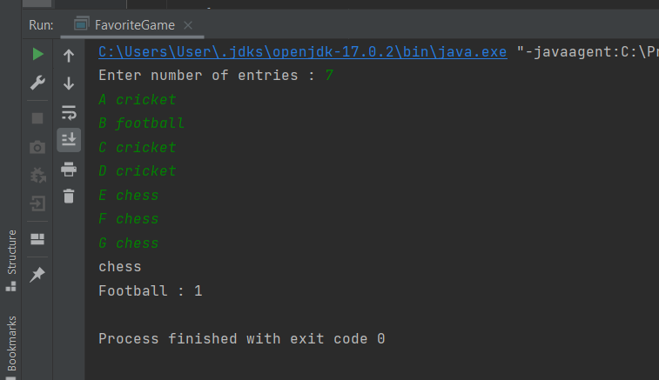

FIGURE 02 - OUTPUT